**MID TERM MINI PROJECT REPORT**

**(2019-20)**

# SNOBBY



**Institute of Engineering & Technology**

**Team Members**

Rachit Chaudhary

(171500248)

Yashika Goyal

(1715000399)

***Supervised By:-***

**Dr. Mr. Manoj Varshney**

(Technical Trainer)

**Department of Computer Engineering & Applications**



SNOBBY Full Stack

**ABSTRACT**

The project online canteen system helps the users to book their food earlier. The users have to book their food on the e-menu card. As soon as they book their food the order will be sent to the chef for preparing it. The present system consists of the manual system that involves the paper work of the billing system and maintaining the files too. In the proposed system the payment is online and the e-menu will be available for the user. The users will have the username and the password through which they can book. This project will help in demonstrating the route from adapting materials to developing an online environment. This brings all necessities in one place that benefits both the user and the canteen owner smartly.

The main objective of online food ordering system is to automate the existing manual system with the help of advanced computerized software so that valuable data can be stored for a longer period with easy accessing and manipulation of the same.The registered user can access the account with valid credentials. User can surf the food items according to categories, Cart and online payment options are available to users. User can track their orders with the food details.In Online Food Ordering System Admin can handle the functionalities like add new food items, edit/delete food items, Enable/Disable the food items according to season and availability. Admin have authority to view order details and update the delivery status of food. The payment transaction and user details are also viewable to admin.

Dept. of CEA,GLAU,Mathura Page 2

SNOBBY Full Stack

**CONTENTS**

Abstract…………………………………………………………………………..…..2

Contents………………………………………………………………………….......3

1. Introduction…………………………………………………………………......4-5
   1. Project Description…………………………………………………………....4
   2. About Full Stack………..……………………………….……………….…....4
   3. Hardware Requirements……………………………………………….…........5
   4. Software Requirements…………………………………………………..........5
   5. Database…………………………………………………………………...…...5
2. Problem Definition………………………………………………………….….......6
3. Objective……………………………………………………………………...…….6
4. Methodology…………………………………………………………………...…..7
5. Implementation Detail……………………………………………………..…….8
6. Contribution Summary…………………………………………………………….9
7. Work Detail……………………………………………………………………......9
8. References……………………………………………………………….…………10



Dept. of CEA,GLAU,Mathura Page 3

SNOBBY Full Stack

**INTRODUCTION**

**Project Description**

The project mainly aims to make the process of placing an order in the cafeteria online. The project will reduce the waiting time from placing an order to getting it.Moreover, it will make the process of giving an order reliable as customers need not carry canteen cards, cash with them and customers don’t have to make lines to place an order at rush times. The project will also further extends its limits by analysing the data collected from the orders which will help the cafeteria to design the menu according to the customers in order to attract them more.

The project solve the issue related to the waiting time after placing an order. The user will be able to place an order online and need not to be present in the canteen itself. After a suitable time, the user may collect its order from the canteen itself showing the receipt of the order or order details.

**About Full Stack**

The area of computer science used in this project is Full Stack. It is most commonly and widely used technology in this era. The most important benefit of this technology is its easy to learn and take less time in implementation. The prerequisites for full stack is not very high just some little basic will be enough to give us awareness.



Dept. of CEA,GLAU,Mathura Page 4

SNOBBY Full Stack

**Hardware Requirements:**

* Processor: Pentium 4 or above
* RAM: 1 GB or Above
* Hard Disk: 40 GB or above

**Software Requirements:**

* Frontend:
  1. HTML
  2. CSS
  3. Javascript
* Backend:
  1. Java script
  2. Python

**Database:**

* MongoDB



Dept. of CEA,GLAU,Mathura Page 5

SNOBBY Full Stack

**PROBLEM DEFINITION**

Feeling hungry but not having enough time to wait for the order is a state which most of us faces almost everyday. The strict criteria of attendance doesn’t allow us to leave the classes just for eating food. But what if we don’t have to wait for the order. What if we just need to have enough time to eat the food. Here, the project,understanding the value of your time, is playing its role by reducing the waiting time to get the order. Order from within the campus and get it without waiting anytime for it to be cooked.

**Advantages**

1. Readily uploads the updates without any delay.
2. User friendliness provided in the website with various control.
3. The project management quite flexible.

**OBJECTIVE**

The project solve the issue related to the waiting time after placing an order. The user will be able to place an order online and need not to be present in the canteen itself. After a suitable time, the user may collect its order from the canteen itself showing the receipt of the order or order details



Dept. of CEA,GLAU,Mathura Page 6

SNOBBY Full Stack

**METHODOLOGY**

**Data Flow Diagram**

Level-1 DFD

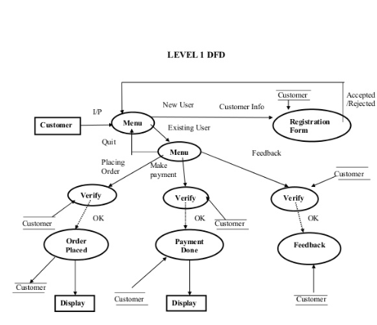

Dept. of CEA,GLAU,Mathura Page 7

SNOBBY Full Stack

**IMPLEMENTATION DETAILS**

Screenshot of the implemented work

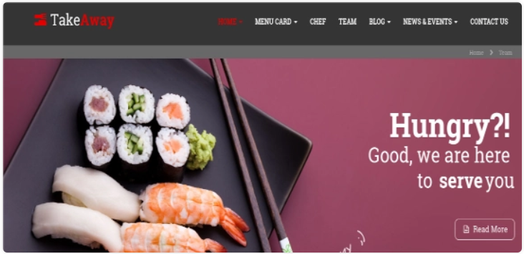

The Home Page of the website has been created keeping in mind the various menu on the home page for the various possible detailed options. Various hyperlinks has been created to move forward to the other different pages.The overall major links required in the project and the various paths are drilled on and are going to be created as soon as possible. The basic structures of the billing process, the cart process, the order selection process, the login process, the registration process has been thought upon and a little styling is remaining to be applied on them.

As the project is concerned about the website, the User’s interaction with the website is mainly focussed and various possible helps at various steps would be provided at the first time to every user in order to make a good understandability of the end-user with the website so that the user feel free to use any functionality provided in the website without seeking help from others.



Dept. of CEA,GLAU,Mathura Page:8

SNOBBY Full Stack

**CONTRIBUTION SUMMARY**

Front end developed by Yashika Goyal.

Back end developed by Rachit Chaudhary.

**WORK DETAIL**

Work done till now:

Front end part is done.

Work left:

Back end part is left.

Dept. of CEA,GLAU,Mathura Page 9

SNOBBY Full Stack

**REFERENCES**

* [www.google.com](http://www.google.com/)
* [www.codepen.io](http://www.codepen.io/)
* [www.udemy.com](http://www.udemy.com)



[1]

1. Dept. of CEA,GLAU,Mathura Page 10